
Company
Logotype

Cone Beam Computed Tomography- Report



Porur Dental X-rays & CBCT

Patient Name : Mrs. Jayanthi | Date of Report : 20.03.2024
Age/ Gender : 53 years/ Male | Region of Interest : CBCT Mandible
Referring doctor: Dr. Selva Ganesh | Indication : Multiple Periapical pathology in relation to lower anteriors.
Clinical Notes: Nil
PATIENT INFORMATION

CBCT Mandible provided
CBCT – IMAGE DETAILS

RADIOGRAPHIC INTERPRETATION

- In relation to the 31, 34, 35, 36, 41, 42, 43 presence of hyperdense crown structure and in 31, 41, 34 presence of hyperdense restorative material involving the pulp canal upto the apical aspect of the roots is evident.
- In relation to the periapical aspect of 31, 41, 42, presence of diffuse periapical hypodense area surrounding the apical aspect of the radicular portion is evident.
- In relation to the crown of 32, diffuse hypodensity involving the enamel, dentin and approximating pulp is evident.
- The hypodense region appears to be at a distance of 4.33 mm from the Lingual artery.

RADIOGRAPHIC IMPRESSION

- Differential Diagnosis (based on the visible radiological features): Root Canal treated teeth with crown and periapical pathology in relation to 31, 41.
- Dental caries with periapical pathology: 32.
- Crown in relation to : 31, 34, 35, 36, 41, 42, 43.


Kindly correlate with clinical and histopathological features

IMAGES FOR REFERENCE

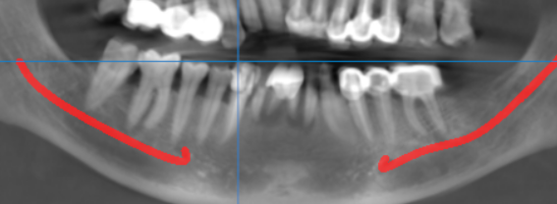

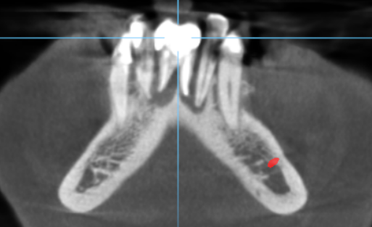
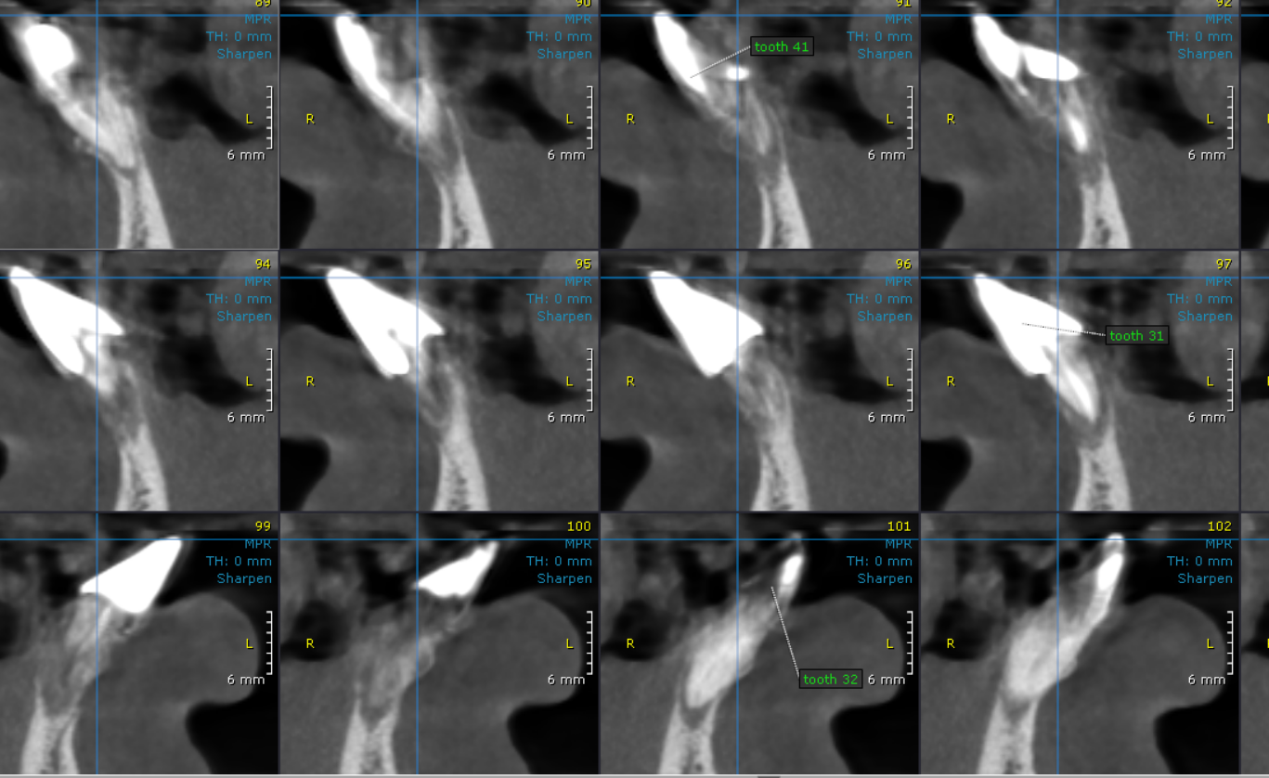
CROSS SECTIONAL IMAGES FOR REFERENCE

3-DIMENSIONAL VIEW

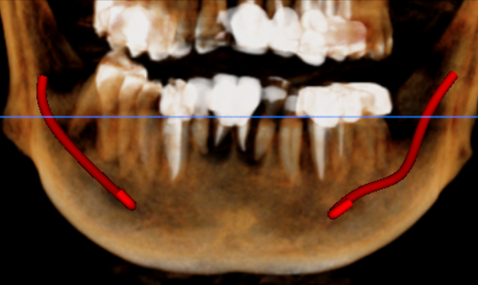

**** End of report ****

